

Student Name | Swapnil Birajdar
SRN No | 31231287
Roll No | 41
Program | AIDS
Year |   Third  Year
Division | A
Subject | Computer Network Laboratory
Assignment No | 2

Assignment Number
-

0
2

Title : Study of Linux and Windows Network commands

Problem Statement Studying Linux and Windows network commands. [ ping, pathping, ipconfig/ifconfig, arp, netstat, nbtstat, nslookup, route, traceroute/tracert, nmap, etc]

Try to execute following commands on linux terminal or Windows command prompt.

o ipconfig / ifconfig o ping o Tracert/Traceroute/Tracepath o NSlookup o Netstat o Hostname o Port Scan / nmap o Arp Route o Whois
• Write description of each command and take snapshot of execution of command through terminal /
command prompt and add after command description.

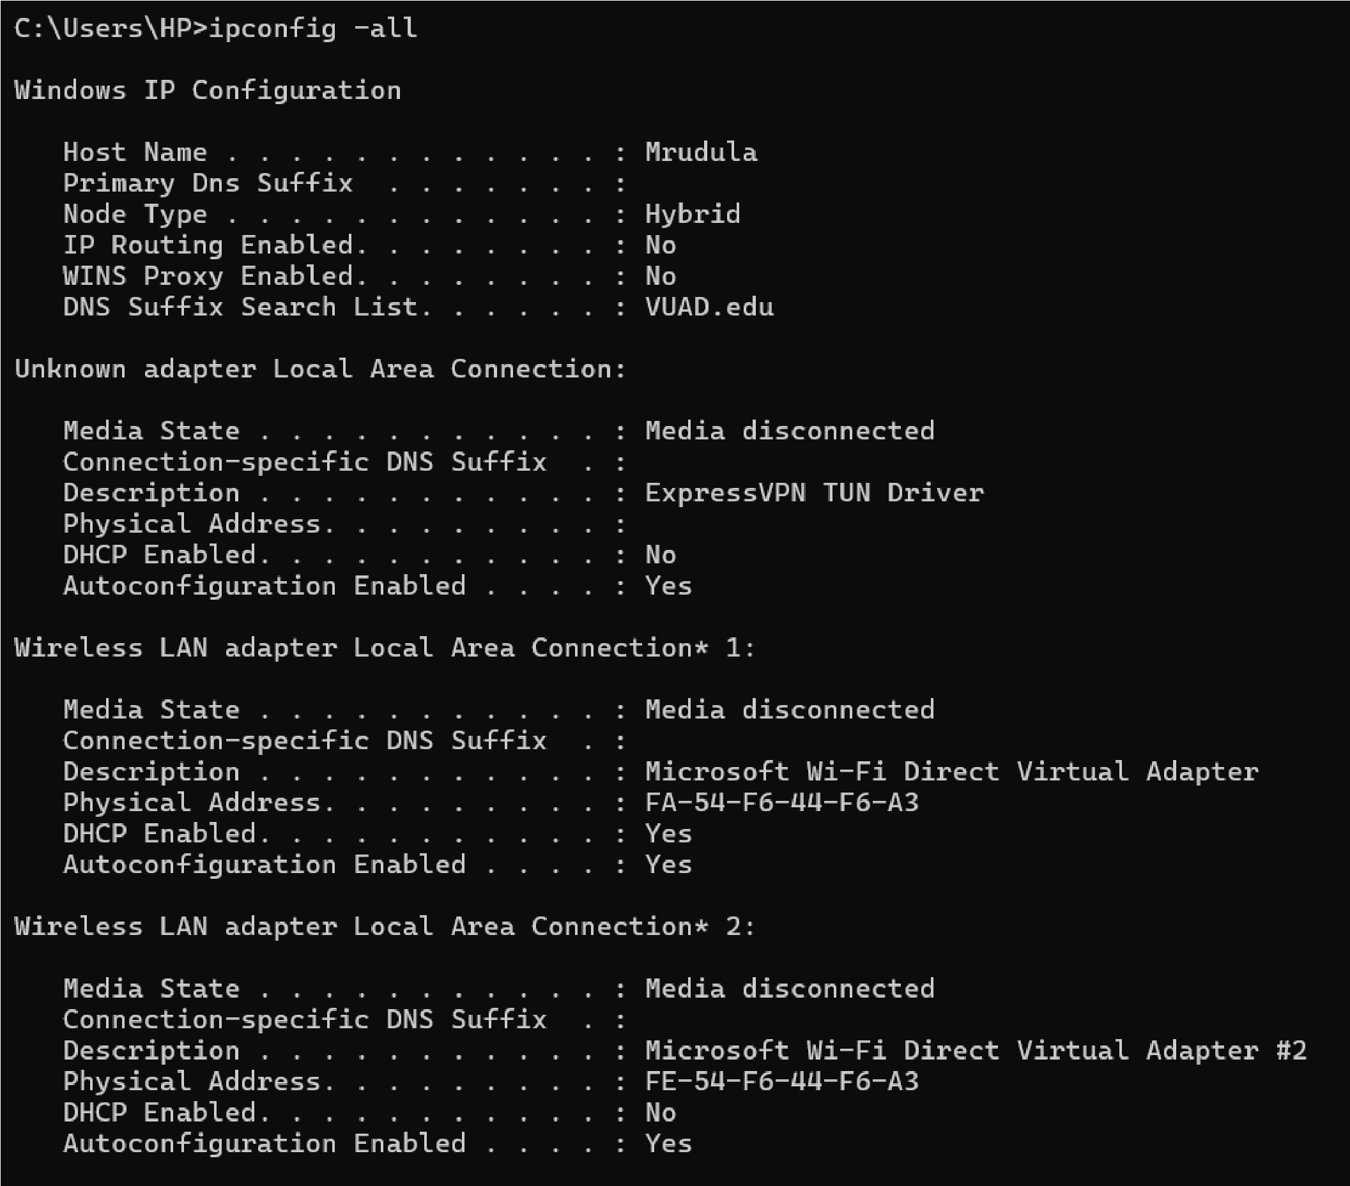
1. Ipconfig – try to run with ipconfig-all

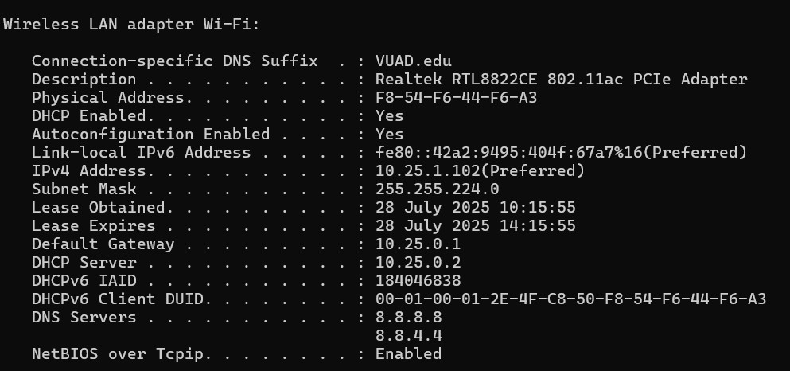

2. Ping

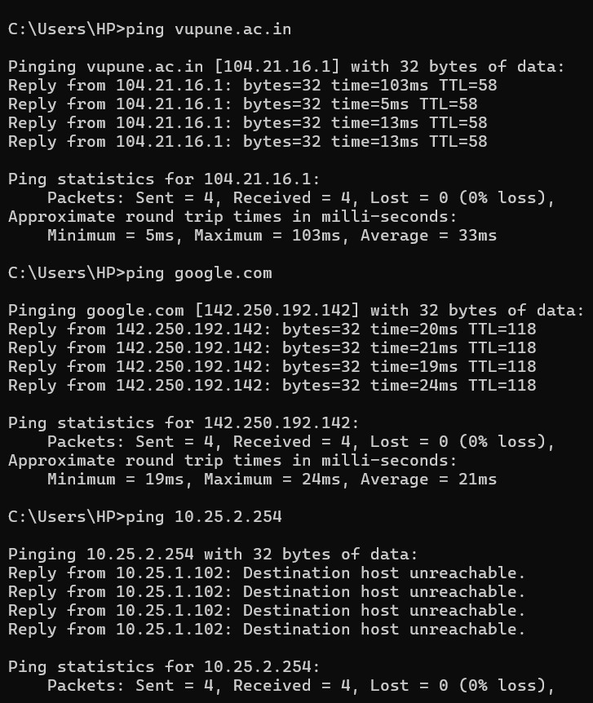

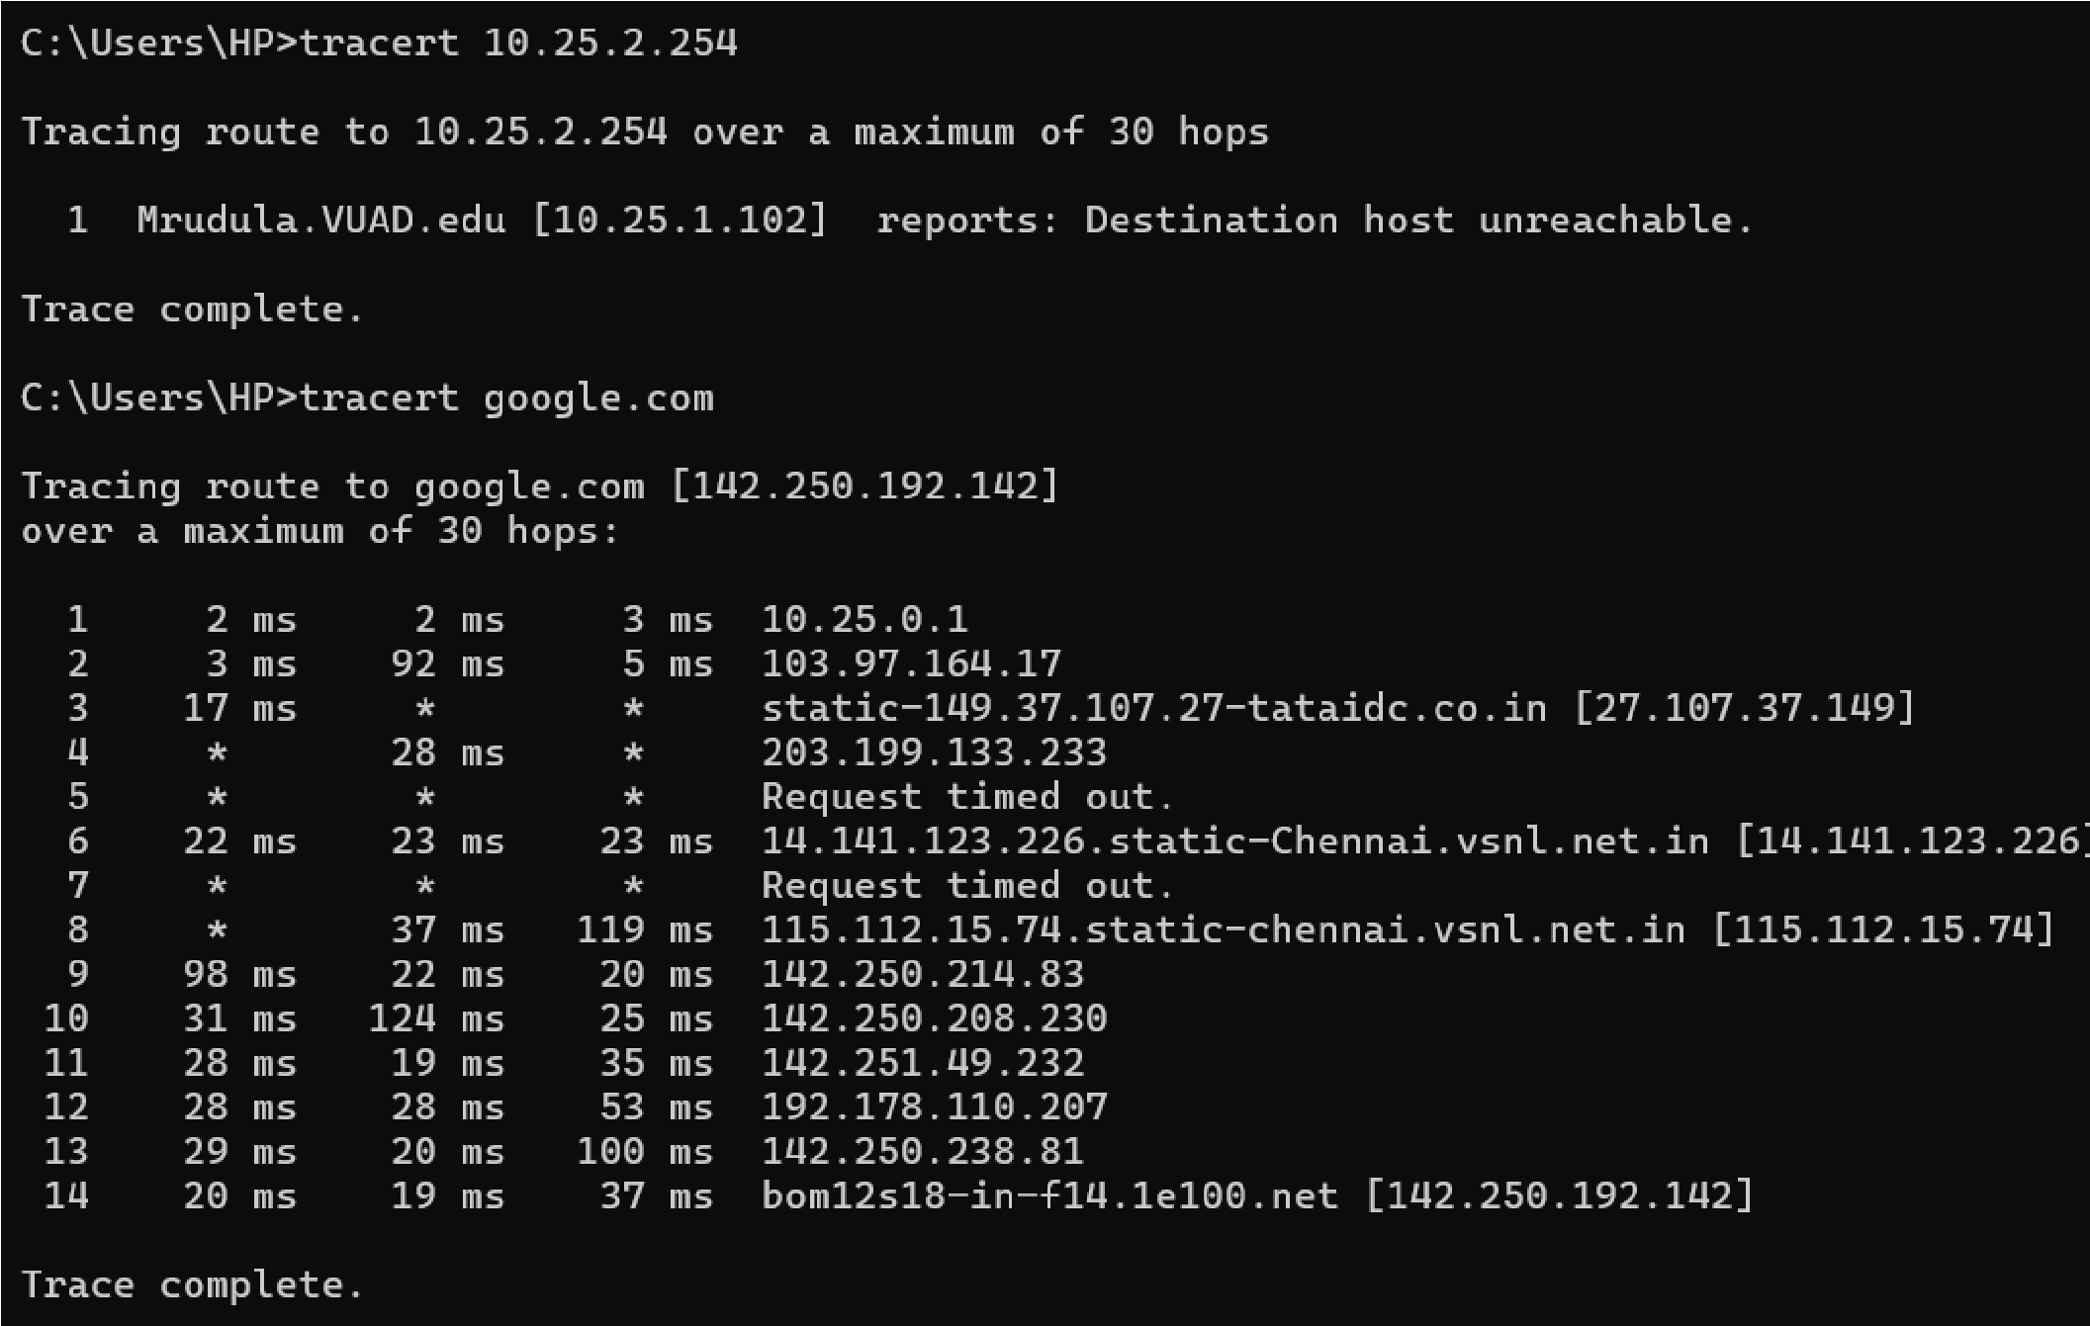
3. Tracert /traceroute

4. Hostname

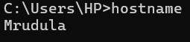

5. Nslookup

